Bonnington Symbol System
City of Edinburgh Council

Symbol resource 2008

including relevant British Standard symbols from BS 8501


Activities
Catering
College
Environments
Health
Home
People
Self development

activities
environments




The Resource
This resource has been created as a series of word documents which may be printed out to use as a visual reference and index.

Copy and Paste/Instructions
To reproduce an image:
- Single click on the image ensuring it is selected
- Select Copy from the Edit menu (or use keyboard shortcut Ctrl+C)
- Open the document you wish to place the image in (e.g. word document)
- Select Paste from the Edit menu (or use keyboard shortcut Ctrl+V)

Images may be resized by dragging in or out from a corner, images may be resized up to A4 without any loss of quality.

Images may be placed in tables or text boxes.

If you have any difficulty using any of the images please contact BSS using the contact details below.

Acknowledgement British Standards: Permission to reproduce extracts from the BS 8501:2002 is granted by BSI. The British Standards can be obtained from BSI Customer Services, 389 Chiswick High Road, London W4 4AL. Tel +44 (0)20 8996 9001

Acknowledgement BSS Edinburgh Council: Permission to reproduce BSS symbols is granted by The City of Edinburgh Council Health and Social Care; however reproduction of any part of the CD ROM in any form is not permitted.

Disclaimer: The City of Edinburgh Council cannot accept any responsibility for damage caused to your computer or data whilst using this CD.

Contact information: Gordon Fraser, Performance Review Manager. The City Of Edinburgh, Health and Social Care, Waverley Court, 4 Market Street Tel: +44 (0)131 553 8266
www.edinburgh.gov.uk/internet/social_care/CEC_learning_disability

 | 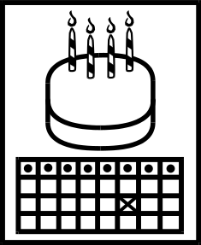 | 
Agreement  6000 | Birthday  6001 | Books on tape  6002
 |  | 
Breakfast  6003 | Budget  6004 | Choices  6005
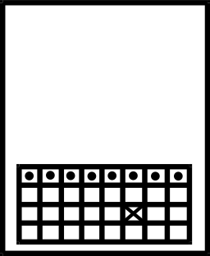 |  | 
Date or appointment  6006 | Day time  6007 | DVD watching  6008
 |  | 
Emergency repairs  6009 | Feel good about yourself-female  6010 | Feel good about yourself-male  6011
Bonnington Symbol System
www.edinburgh.gov.uk
 |  | 
Feelings  6012 | Feelings-happy  6013 | Feelings-okay  6014
 |  | 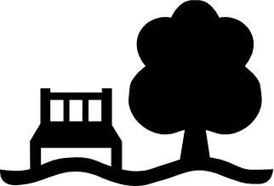
Feelings-sad  6015 | Fire assembly point  6016 | Garden  6017
 |  | 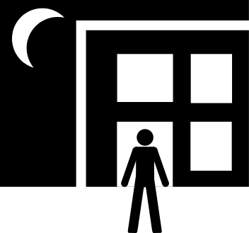
Going out-cafe  BS 8501 8067 | Going out-cinema  BS 8501 8002 | Going out-evening social club  6018
 | 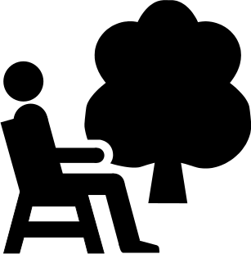 | 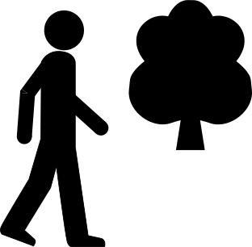
Going out-pub  6019  Bonnington Symbol System  www.edinburgh.gov.uk | Going out-public park  BS 8501 8040 | Going out-walk in country  6020
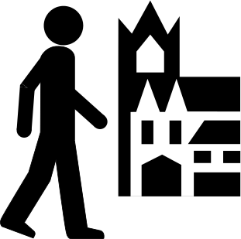 |  | 
Going out-walk in town  BS 8501 8035 | Help and support  6021 | Holidays  6022
 | 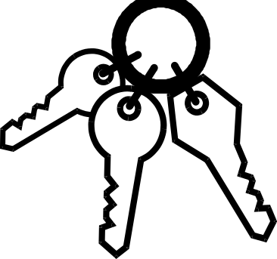 | 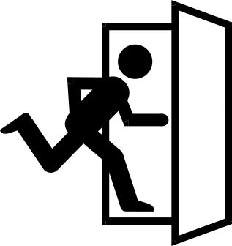
Keep safe  6023 | Keys  6024 | Late  6025
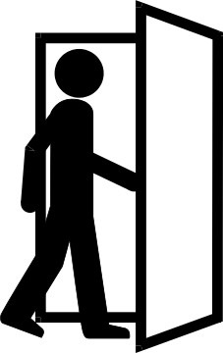 | 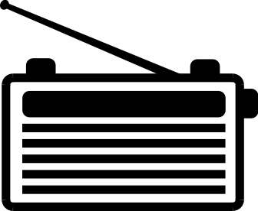 | 
Leaving  6026 | Listen to Radio  6027 | Listen to music CD  6028
 |  | 
Meal time  6029  Bonnington Symbol System  www.edinburgh.gov.uk | Mobile phone  6030 | Night time  6031
 | 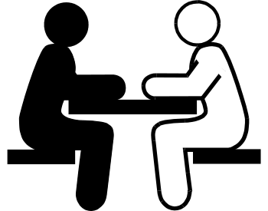 | 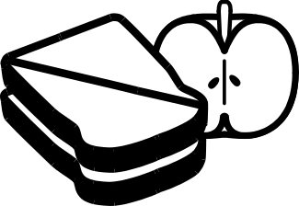
No smoking  BS 8501 6029 | One-one discussion  6032 | Packed lunch  6033
 | 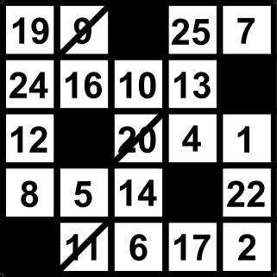 | 
Playing-beetle  6034 | Playing-bingo  6035 | Playing-computer game  6036
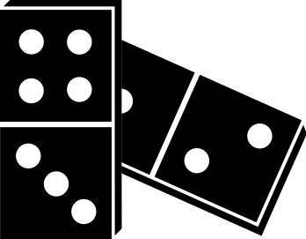 | 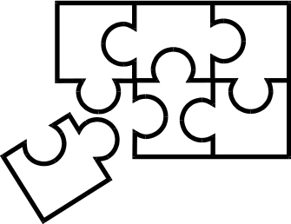 | 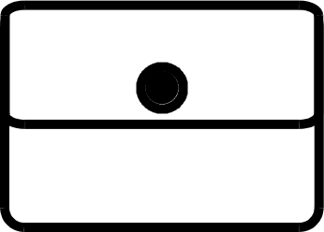
Playing-dominoes  6037 | Playing-jigsaw  6038 | Purse  6039
 |  | 
Questions  6040 | Rating-good  6041 | Rating-not good  6042

Bonnington Symbol System
www.edinburgh.gov.uk

 |  | 
Rating-right  6043 | Rating-wrong  6044 | Relationships-being polite  6045
 |  | 
Relationships-getting along  6046 | Relationships-not getting on #1  6047 | Relationships-not getting on #2  6048
 | 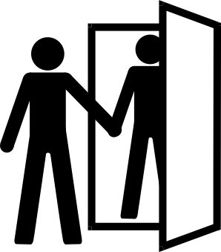 | 
Relationships-not getting on #3  6049 | Relationships-visitors  6050 | Religion  6051
 | 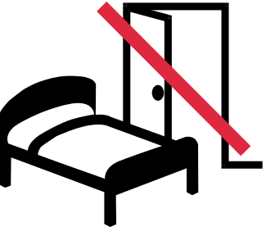 | 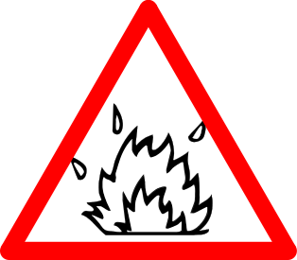
Respite  6052 | Rules-bedrooms  6053 | Rules-fire safety  6054
Bonnington Symbol System
www.edinburgh.gov.uk

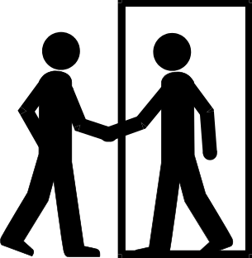
Rules-going into other rooms  6055 | Rules-going out  6056 | Rules-meal times  6057
 |  | 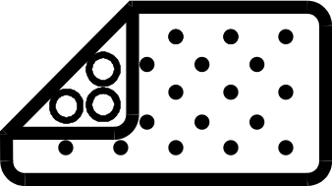
Rules-using computer  6058 | Rules-using shower  BS 8501 5013 | Rules-using shower- bathmat  6059
 |  | 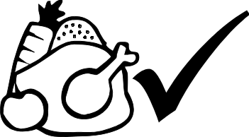
Rules-using shower-temperature  6060 | Self care-bath  BS 8501 5014 | Self care-eat well  6061
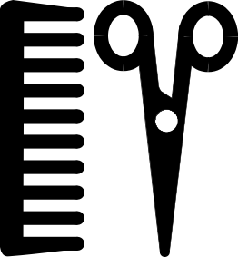 | 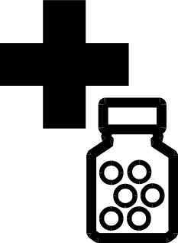 | 
Self care-hair  BS 8501 6014  Bonnington Symbol System  www.edinburgh.gov.uk | Self care-medication  6062 | Self care-money  6063

 | 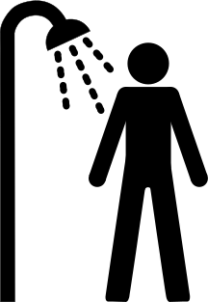 | 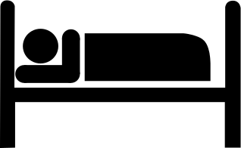
Self care-shower #1  BS 8501 5013 | Self care-shower #2  6064 | Self care-sleep  6065
 | 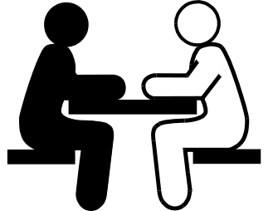 | 
Smoking  6066 | Talking about problems  6067 | Task-basic cleaning  6068
 | 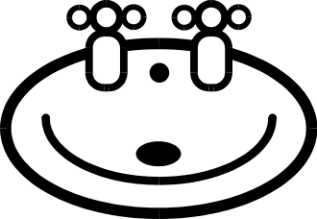 | 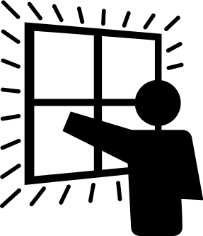
Task-cleaning bath  6069 | Task-clean basin  6070 | Task--clean windows  6071
 | 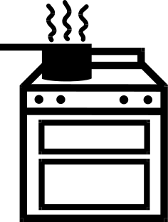 | 
Task-clear away dishes  6072 | Task-cooking  6073 | Task-do the dishes  6074
Bonnington Symbol System
www.edinburgh.gov.uk

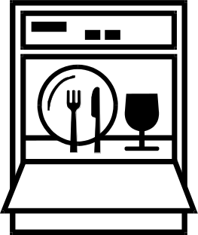 | 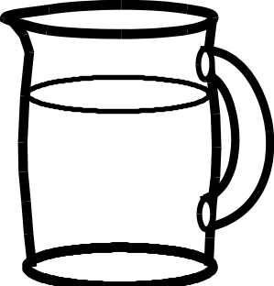 | 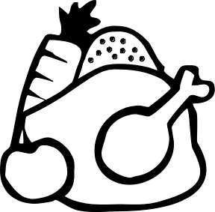
Task-fill or empty dishwasher  6075 | Task-fill water jug  6076 | Task-food planning  6077
 |  | 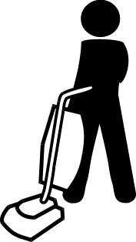
Task-gardening  6078 | Task-hang up clothes  6079 | Task-hoovering  6080
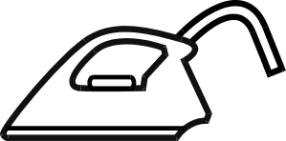 | 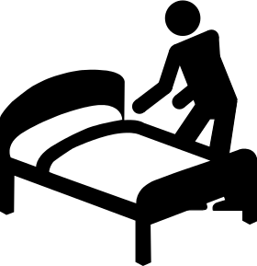 | 
Task-ironing  6081 | Task-making bed  6082 | Task-peel potatoes  6083
 | 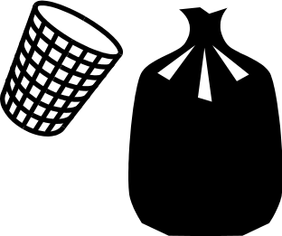 | 
Task-put clothes away  6084 | Task-put rubbish out  6085 | Task-set table  6086
Bonnington Symbol System
www.edinburgh.gov.uk

 |  | 
Task-sweep floor  6087 | Task-take rubbish out to wheelie bin  6088 | Task-tidy up  6089
 |  | 
Task-wash clothes  6090 | Task-wipe surfaces  6091 | Telephone  BS 8501 6003
 | 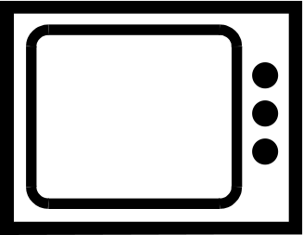 | 
Television-off  6092 | Television-on  6093 | Things to do  6094
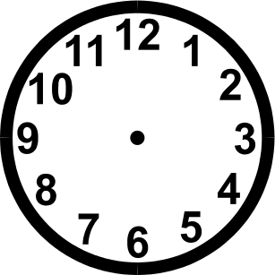 |  | 
Time  6095 | Transport-bus pass  6096 | Transport-car  6097
Bonnington Symbol System
www.edinburgh.gov.uk

 | 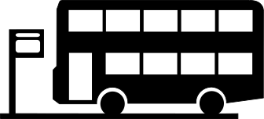 | 
Transport-minibus  6098 | Transport-public transport #1  6099 | Transport-public transport #2  6100
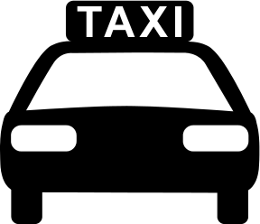 | 
Transport-taxi #1  BS 8501 7007 | Transport-taxi #2  6101 | Using computer  6102
 |  | 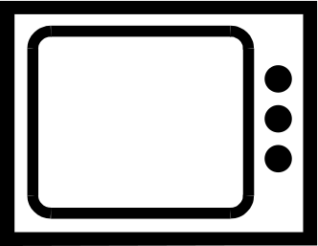
Wash your hands #1  6103 | Wash your hands #2  6104 | Watch television  6105

Your thoughts
6106
Bonnington Symbol System
www.edinburgh.gov.uk

